Case 5-Asia-China-Hongshan-Bi Disk-4 Notch-Black-3500-2200 BCE

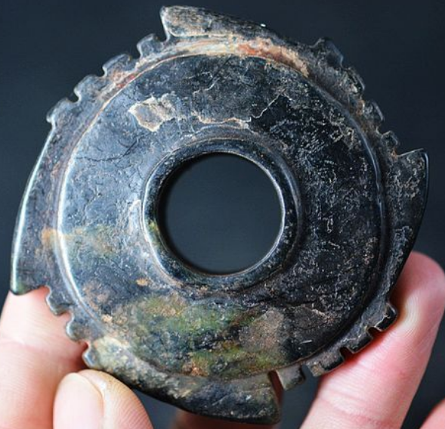 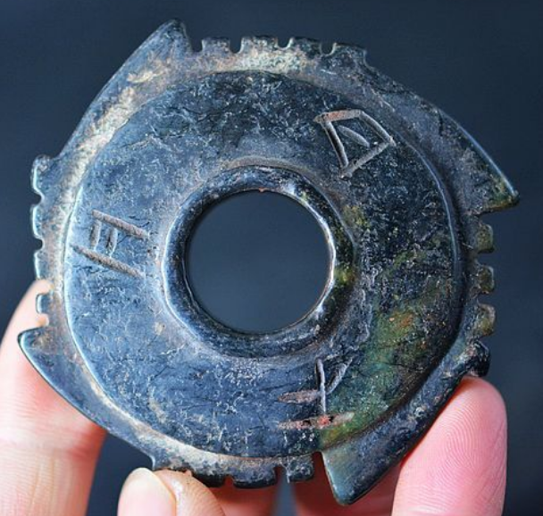

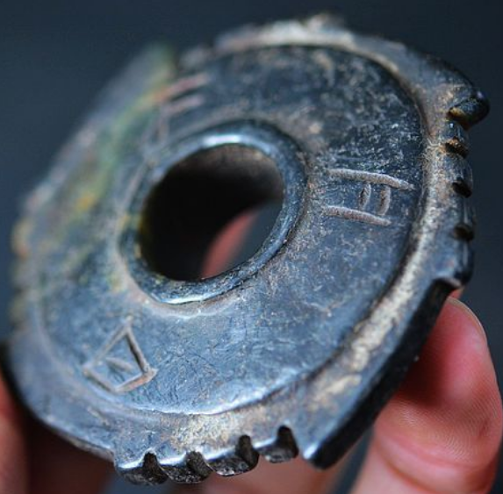

Figs 1-3. China-Hongshan-Bi Disk-4 Notch-Black-3500-2200 BCE

**Case no.: 5**

**Accession Number:**

**Formal Label:** China-Hongshan-Bi Disk-4 Notch-4 Serrations-Celadon Silicate-3500-2200 BCE

**Display Description:**

**LC Classification:**

**Date or Time Horizon:**

**Geographical Area:**

**Map:**

**GPS coordinates:**

**Cultural Affiliation:**

**Media:**

**Dimensions:**

**Weight:**

**Condition:**

**Provenance:**

**Discussion:**

In contrast to the Graeco-Roman and Judaeo-Christian-Muslim notions of the soul of humans as the immaterial (or spiritual) essence of a human Being, the Hongshan people of ancient Northeast Eurasia (also known as Northeast China) regarded the souls of both humans and animals as both immaterial *and* material. That is, the souls of both were tangible and accessible through psychometry. Secondly, they did not regard humans as ontologically superior to animals but as equals. What follows is a short description of the origins of Hongshan symbolism as it follows from these two standpoints.

1) Transitional Hunter-gatherer / Neolithic cultures of Northeastern Eurasia attest to the beginnings of agriculture by the presence of domesticated phytoliths that were excavated with solely wild faunal remains at four sites at the Nanzhuangtou site (39° N lat). in Xushui County, Hebei (Huang 1966; Yan 1997:, Baoding Institute et al. 1992), at the Yucanyan site in Dao County, Hunan, at 25.5° N lat. and at the Xianrendong and Diaotonghuan sites (28.5° N lat.) in Wannian County, Jiangxi (Yan 1997).

At ca 6,000 BCE Asians with the D haplogroup living in the Yangtze River delta domesticated both wild boars and foxtail millet (Wu et al. 2007). At the Cishan site in Hebei, Wu’an County (36.5° N lat.) (Jing and Flad 2002) burial pits of domesticated wild boars were overlain by charred, domesticated foxtail millet (Jing and Flad 2002; Jing et al. 2008). Domesticated foxtail millet, a C4 plant that cycles CO2 into four-carbon sugar compounds, is very efficient in hot, dry climates and was an important component of both the human and swine diets (Jing and Flad 2002). The discarded chaff of domesticated cereals appears to have been used to feed wild boars. Domesticated wild boars have been identified by tooth size (lower 3rd molar, L41.4, W 18.3), age at slaughter (> 60%, .5-1 yr.) and archaeological context such as ritual burial of entire skeletons beneath charred foxtail millet.

These Transitional Hunter-gatherers were the emergent Neolithic Hongshan people, who secured economic control over foxtail millet and wild boars and through these sources of productive wealth consolidated their political power. Interestingly, these were speakers of Altaic, a language either pre-Mongolic or Korean but *not* Sinitic (Blench 2004; but see Guo 1995).

By 6000 BCE the Yangtze River delta had emerged as an area of importance for the development of a dual domesticated boar and foxtail millet economy. Within a Neolithic time-horizon of 6000-2200 BCE a Hongshan Boar Symbolism was developed that was integrated into jade objects produced by élite artisans for political élites which were beyond the reach of commoners. In order to gain the respect of the masses political élites doled out these prestige goods to the commoners not only millet and pork (Flannery 1968, Bradley 1972, Frankenstein and Rowlands 1978, Kristiansen 1991, Saenz 1991) but also jade and silk (Firth 1965; Leach 1970:162-63).

**References**

Anderson, E. N., JR. I988. *The food of China.* New Haven: Yale University Press.

Blench, Roger. 2004. “Human migrations in continental East Asia and Taiwan: genetic, linguistic and archaeological evidence. Université de Genève” [DRAFT CIRCULATED FOR COMMENT]

Chang K. C. I977. *Food in Chinese culture*. New Haven: Yale University Press.

1986. 4th edition. *The archaeology of ancient China*. New Haven: Yale University Press.

1989. "Ancient China and its anthropological significance." In *Archaeological thought in America*. Edited by C. C. Lamberg-Karlovsky, pp. I 55-66. Cambridge: Cambridge University Press.

Childs-Johnson, Elizabeth (1991). "Jades of the Hongshan culture: the dragon and fertility cult worship," Arts asiatiques, **46**: 82–95.

Cohen, M. N., and G. J. Armelagos.1. *Paleopathology at the origins of agriculture*. Orlando: Academic Press.

Freid, M. H. I967. The evolution of political society. New York: Random House.

Freidman, J., and M. J. Rowlands. I978. "Notes towards an epigenetic model of 'civilization,"' in *The evolution of social system*. Edited by J. Friedman and M. Rowlands, pp. 20I-76. London: Duckworth.

Gao, G. I978. “Dawenkou culture its nature and chronology” (大汶口文化的性质和年代), *Kuangmingribao*, April 27.

Guo, Da-Shun 1995. Hongshan and related cultures. In: *The archaeology of Northeast China: beyond the Great Wall.* Nelson, Sarah M. ed. 21-64. London and New York: Routledge.

Guo D. *Hongshan Culture(红山文化*). Artifacts Press; Beijing: 1985.

Jiang W, et al. 2006. Reconstruction of climate and vegetation changes of Lake Bayanchagan (Inner Mongolia): Holocene variability of the East Asian monsoon. Quat Res. 65(3):411–420.

Jin, G. and Liu, D. 2002. Mid-Holocene climate change in North China, and the effect on cultural development. *Chinese Science Bulletin*, *47*(5), pp.408-413.

Jing Y, Flad R. 2002.” Pig domestication in ancient China,”. Antiquity 76: 724–732.

Jing Y, Jianlin H, Blench R. 2008. “Livestock in ancient China: an archaeo-zoological perspective.” In: Sanchez-Mazas A, Blench RM, Ross M, eds. Human Migrations in Continental East Asia and Taiwan. Genetic, Linguistic and Archaeological Evidence. Routledge; Abingdon: New York.

Johnson, A. W., and T. Earle I987. *The evolution of human society: From foraging group to agrarian state*. Stanford: Stanford University Press.

Keibel F. 1897. *Normentafeln zur Entwicklungsgeschichte der Wirbelthiere*, (*Sus scrofa domesticus*). Bd. 1. Jena: Fisher, v. 1, pl. 2, no. 16.

Kaogu. I979. “Summary of the debate on the nature of Dawenkou society and related questions (关于大汶口社会性质辩论及相关问题的总结),” *Kaogu*, no. I, pp. 33-36.

Larson G, Dobney K, Albarella U, Fang M, Matisoo-Smith E, Robins J et al. 2005. “Worldwide phylogeography of wild boar reveals multiple centers of pig domestication,” *Science* 307: 1618–1621.

Larson G, Liu R, Zhao X, Yuan J, Fuller D, Barton L et al. 2010. « Patterns of East Asian pig domestication, migration, and turnover revealed by modern and ancient DNA,” *Proc Natl Acad Sci USA* 107: 7686–7691.

Lee, Y. I96I. “Mortuary practices of Wa people and the research on burial practices in prehistoric China (佤族的太平间做法，在中国史前丧葬习俗研究),” *Kaogu*, no. 7, pp. 37I-74.

Rappaport, R. 1967. *Pigs for the ancestors*. New Haven: Yale University Press.

Sahlins, M. A. I970. "Poor man, rich man, big-man, chief: Political types in Melanesia and Polynesia," in *Cultures of the Pacific*. Edited by T. G. Harding and B. J. Wallace, pp. 203-I5. New York: Free Press. . I972. Stone Age economics. New York: Aldine.

Sanders, W. T., and D. Webster. I978. "Unilinealism, multilinealism, and the evolution of complex societies," in *Social archaeology: Beyond subsistence and dating*. Edited by C. Redman, M. Berman, E. Curtis, W. Langhorne, N. Veraggi, and J. Wanser, pp. 249-302. New York: Academic Press.

Saxe, A. I970. *Social dimensions of mortuary practices*. Ann Arbor: University Microfilms.

Service. 1962. *Primitive social organization*. New York: Random House.

I975. *Origins of the state and civilization*. New York: Norton.

Shandong Provincial Museum. *I978.* “Remarks on Dawenkou culture (论大汶口文化),” *Wenwu,* no. 4, pp. 58-66.

Tang, L. I977. Origins of earliest culture in China as seen from the writing on pottery (从陶器文字看中国最早的文化起源). *Kuangmingribao*, July I4.

I978. “A discussion of the nature of the Dawenkou culture and the writing on pottery (论大汶口文化的性质与陶瓷文字),” *Kuangmingribao,* February 23.

Taylor, D. I975. “Some locational aspects of middle-range hierarchical societies.” Ph.D. diss., City University of New York.

Tong C. I974. “The origins of private ownership and social stratification in Chinese archaeology,” *Kaogu,* no. 4, pp. 2I3-2I.

Wang, R. I98I. “The religious significance of interring pig carcasses in the Chinese Neolithic (中国新石器时代中国猪尸屠体的宗教意义),” *Wenwu*, no. 2, pp. 79-85.

Wei, J. I976. “Discussion of origins of hierarchical societies in ancient China: An analysis of archaeological data in prehistoric societies (中国古代等级制社会的起源：史前社会考古资料分析),” *Wenwu*, no. 8, pp. I-5.

Wu, J. 1982. “The chronology of Shandong archaeology and related questions (山东考古年表及相关问题),” *Wenwu*, no. IO, pp. 44-56.

Wright, H. I984. "Pre-state political formations," in *On the evolution of complex societies*. Edited by T. Earle, pp. 47-77. Malibu: Undena.

Yang, X., L.A. Scuderi, X. Wang, L.J. Scuderi, D. Zhang D., H. Li, S. Forman, Q. Xu, R. Wang, W. Huang, S. Yang. 2015. “Groundwater sapping as the cause of irreversible desertification of Hunshandake Sandy Lands, Inner Mongolia, northern China,” [*Proc Natl Acad Sci U S A*.](https://www.ncbi.nlm.nih.gov/pubmed/25561539)  Jan 20;112(3):702-6.